**ANNEXES**

**Annex A - St+art Delhi 2019**

Since inception in 2014, the St+art has worked tirelessly towards its vision of making art accessible to everyone through transforming public spaces and creating open-air public art galleries, which not only ignite conversation but also increase community pride and interaction.

This year, St+art Delhi 2019, will include, an expansion of the flagship project – (i) The Lodhi Art District with an addition of more than 20 new murals, (ii) an immersive art exhibition – F(r)iction at KONA, that will represent the discourse on the changing nature of the relationship between Art, Nature and Technology at Jor Bagh and, (iii) a special focus on increasing community participation at Lodhi Colony and surrounding areas. The festival will see participation from over 30 creators including artists, musicians, chefs and performers, and will run for 6 weeks until mid-march 2019.A true celebration of diversity, cultures and inclusivity, making art accessible to all.

**Annex B – List of Singapore Artists at Lodhi Art Colony**

**Artist: Brandon Tay**

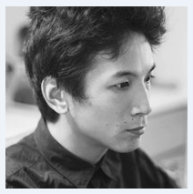

**Profile:** A multimedia artist from Singapore, Brandon Tay mesmerises his audiences through audio-visual performances and moving images in the fields of projection mapping, live AV, motion graphics, mediated sculptures and music videos. With over 6 years of experience in both Singapore and Melbourne he has worked on multiple platforms like the music video collective KROZM on clips for brands like Cut Copy, Van She, and Midnight Juggernauts. His works have been displayed in the National Museum Singapore, National Gallery Singapore, Singapore Art Museum, and in various other galleries and museums outside of the country.

**Work in Singapore Weekender:** The artist will be displaying a new media interactive installation called Facade in Kona which will display the combined use of exotic artefacts with CGI heads. The display will project elements of a bookshelf that will be juxtaposed with visuals of facial transmogrifications on screens. This abstraction signifies the determined nature of truth in the face of distracting movements of perception. The exhibit would sleep, wake, and dream, owing to the time of the day; and would also animatedly yawn, blink and stare, showcasing a range of facial expressions. The heads will be placed in a manner which tracks the movements of viewers, the eyes of bust following the movements of people in the space.

**Artist: Tan Xi Zi**

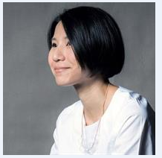

**Profile:** The Singaporean illustrator and artist Tan Xi Zi graduated in 2009 with an honours degree in graphic design, from London. Since then, her prolific works have won her praise. Her moniker, MessyMsxi that has an alliterative ring to it is derived from her belief that true works of art come from moments of spontaneity and inspiration. She finds herself indulging in a variety of mediums and apart from her commercial projects has also collaborated with graphic designers, fashion labels and museums for a varied set of projects that included public displays.

**Work in Singapore Weekender:** After her thought provoking, ‘Plastic Ocean’ exhibit in Mumbai in 2017 which gained severe international acknowledgement, Tan Xi Zi will captivate audiences in Delhi’s Lodhi Colony, as she will explore new themes and possibilities to explore how nature and technology connect within urban landscapes.

**Artist: Eugene Soh**

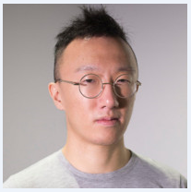

**Profile:** The ‘accidental’ artist Eugene Soh, a.k.a DUDE became an artist when his photographic piece contextualising Da Vinci’s Last Supper showcased on social media in 2012. He is one of the top photo artists in Singapore and his displays comprise of a witty and humorous commentary on the social life and contemporary issues of a modern city-state. With a humanistic and an empathetic angle to his work, Eugene’s parodies of the living conditions in Singapore strike a chord with people of all ages. His satirical commentary implies a greater underlying message that makes this computer programmer a great artist.

**Work in Singapore Weekender:** The artist is going to install an AR piece within Lodhi that will be on view from the 15th Feb onwards. The artist will also be taking an AR workshop for students who are interested in learning the technique to create art experiences using unique methods.

**Artist: Yok & Sheryo**

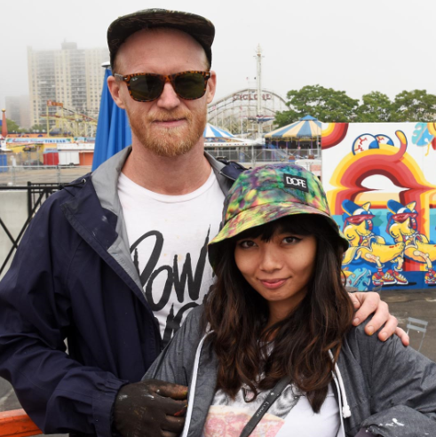

**Profile:** Originally from Australia and Singapore, the street artists Yok and Sheryo have been taking the art world by storm through their enchanting street paintings. They have journeyed from Singapore and Australia, to Perth, and New York, and their work has been displayed in galleries from Hong Kong to London. Their charming personalities that are manifested in their spooky yet oddly cheerful exhibits are a reason for their worldwide recognition. The time they spent in the South East of Asia, got them acquainted with the country’s culture, music, surfing and skateboarding which led to their distinctive style of work.

**Work in Singapore Weekender:** The duo will be creating an installation called, 'The Temple of Self-Indulgence' for an experimental exhibition in Kona, 1 Jor Bagh that will respond to our dependence on social media and virtual reality networks in the contemporary present. They will also be taking a workshop in Lodhi Colony and creating a mural in Lodhi that will respond to local narratives and stories of Lodhi.

**Artist: Yip Yew Chong**

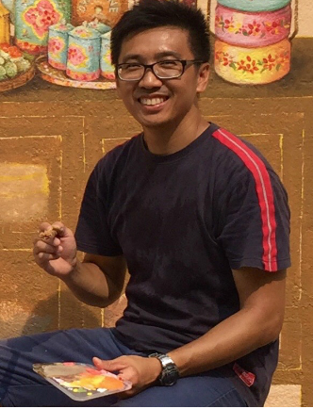

**Profile:** Yip Yew Chong is a Singaporean who fancies sketching and painting, travel, nature, videography, and photography. He blends his mural paintings with sights, sounds, smells, and tastes which bring out the exhibits in a more romanticised way. He often finds himself travelling to offbeat places and enjoys being inspired by their unique lands, cultures, and the offerings of nature. This he captures in memories and photographs to help him come up with more of his alluring art.

**Work in Singapore Weekender:** Yip Yew Chong will be creating a mural in Lodhi Colony that will directly respond to the visual and cultural ecosystem of the various micro communities of Lodhi Colony. He will also be taking a workshop that will lead into smaller interventions around Lodhi and direct a direct and intimate interaction with the residents.

**Artist: Knuckles and Notch**

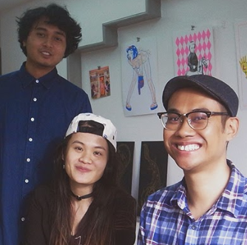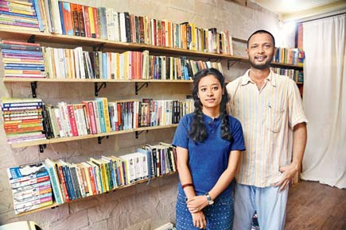

*Knuckles and Notch (Left) and Bombay Underground (Right)*

**Profile:** Driven by curiosity and fascination Knuckles and Notch is a design practice held by three creative people: Djohan Hanapi, Marilyn Yunjin, and Muhammad Izdi. Their studio encourages the exploration and development of the Risograph practice. Their approach involves the appreciation of all things that exist beyond the boundary of what is generally considered to be normal. A challenge to the world of print and publication, their work is a collective desire to capture things that are both real and fantastical and articulate them through publications, posters, prints, and events.

**Work in Singapore Weekender:** The SG based print collective will be hosting a pop up exhibition with zines, posters, design merchandise from all around the world during the SG weekender along with Mumbai based collective Bombay Underground and Delhi based collective Working Hours Collective.

**Artist: Sam Lo**

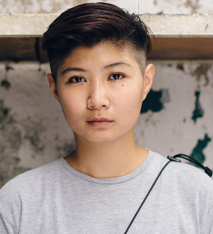

**Profile:** Samantha Lo colloquially known as the ‘Sticker Lady’ is one of Singapore’s most renowned street artists. She is an urban visual artist and works with a wide array of mediums like sculpting, watercolours, wheat-paste, spray-paints to name a few. In 2009, Lo founded an online magazine-RCGNTN-to help the local artists gain recognition and have a better chance at showcasing their talents. In 2015, she hosted her first solo exhibition called the “LIMPEH show” which consisted of portraits featuring Singapore’s late founding father Lee Kuan Yew. The inspiration to her work comes from her observations on the socio-political setting.

**Work in Singapore Weekender:** True to the name awarded to her, Sam would be hosting a sticker workshop to encourage visitors to participate in the merriment. She will also be creating a mural at the festival.

**Annex C – Atypical Singapore Showcase**

As part of the global campaign, Passion Made Possible, Singapore Tourism Board (STB) and Chan + Hori Contemporary have collaborated to launch the showcase Atypical Singapore. The exhibition features art from seven contemporary artists handpicked by Chan + Hori Contemporary’s curatorial director and partner, Khairuddin Hori. Art and technology studio Meshminds and artist Eugene Soh also developed Augmented Reality (AR) technology for selected artworks and AR namecards, bringing them to life in a medium that allowed for an interactive experience and new perspectives of art.

The artists – Daniel Yu, Gerald Leow, Speak Cryptic (Farizwan Fajari), Amanda Tan, Eugene Soh, anGie seah and Muhammad Izdi – have practices that range from performance art and sculpture, to animation and painting. Together, they provide a multi-sensory experience that helps bring a taste of the diversity that exists in Singapore’s art eco-system to an international audience.

**About Khairuddin Hori**: Khai is best known for his multidisciplinary and unconventional approach to curating, supported by his experience in theatre and work as an artist.

Khai’s profile was placed under the spotlight in 2014 after he was personally invited by the President of Palais de Tokyo in Paris, Mr Jean de Loisy, on board Europe’s largest and internationally renowned art center as its Deputy Director of Artistic Programming. Prior to that, Khai was Senior Curator at the Singapore Art Museum, overseeing the national collection of contemporary art, and Senior Curator at the Curatorial Development department of the National Heritage Board.

**About Daniel Yu:** Daniel Yu is a Singaporean sculptor who works primarily in the medium of clay and resin. Heavily influenced by an upbringing steeped in local tradition, as well as pop culture ephemera, his works combine both worlds of imagination.

His investigations centre on the intrinsic value of memory and the use of storytelling as a tool that highlights social and cultural similarities. His works offer a means of escapism from the real world, yet remain largely shaped by his personal experiences.

Daniel’s fictitious characters see a cult following amongst the urban and subculture art scene in both Singapore and abroad.

**About Gerald Leow:** Self-taught as an artist, Gerald’s interests include houses, anthropology and material cultures.

In January 2018, Leow presented Harvest, a 3.7 meter tall outdoor sculpture resembling a traditional rice granary commissioned by the Singapore Art Museum He was also included in LOCK ROUTE (Gillman Barracks, Singapore) 2017, Secret Archipelago (Palais de Tokyo, Paris) 2015, The Singapore Show: Future Proof at the Singapore Art Museum at 8Q (Singapore) 2010. A diverse arts practitioner, he works frequently in theatre creating sets and objects and is also part of the visual art collective DXXXX.

**About Speak Cryptic (Farizwan Fajari):** Inspired by the visual language prevalent within the cultures of comics and underground music, Speak Cryptic’s works primarily deal with the issues pertaining to the human condition. Utilising personal iconographies and a cast of characters that he has developed over the years, he applies them to various narratives inspired by his observations on current affairs and his immediate environment.

His previous exhibitions include a solo show at Officina Delle Zattere in Venice, Italy in 2015 and group exhibitions such as Secret Archipelago (Paris, 2015), Singapore Biennale (2013), Budi Daya (2014) and Future Proof (2012). He is a member of the DXXXXD Collective and plays the electric bass for the Singaporean based band, I AM DAVID SPARKLE.

**About Amanda Tan:** Amanda is a filmmaker, director, visual designer, writer and artist based in Singapore. Her music videos and short films have been screened and nominated for awards at various film festivals, including the NYC Indie Film Awards, Singapore Short Film Festival, Salento International Film Festival in Italy and Singapore Short Film Awards.

With an understanding of pop and alternative culture, she is able to create mainstream work that still appeals to the masses, as well as those to the left of center.

**About Eugene Soh:** Eugene Soh’s images parody iconic works of art while providing a tongue-in-cheek commentary on contemporary life in Singapore.

The many elements and characters in his works represent multiple narratives within a distinctly Singaporean context. He uses his technological expertise to manipulate various forms of digital art, constantly aspiring towards new ways to share his work.

Soh’s works were recently exhibited at the ICON Martell Photography Prize 2014, National Museum of Singapore and Sensorium 360, Singapore Art Museum.

**About anGie seah:** anGie seah’s multidisciplinary practice traverses the mediums of drawing, installation, performance and sound to respond to the human condition in relation to the social environment. In 2000, she was awarded an education bursary from National Arts Council, graduating from the Royal Melbourne Institute of Technology with a Bachelor of Arts, majoring in sculpture.

Since 1997, anGie has exhibited works, taken part in artist residencies and participated in performance art festivals in locations such as Belgium (Les Halles de Schaerbeek), Germany (ZKM Centre for new media), Japan (Fukuoka Asian Art Museum), Australia (Asialink/VCA), France ( Palais de Tokyo, MAC lyon), Poland (Galeria Labirynt), Singapore (Singapore Biennale 2013) and Sweden (Uppsala Art Museum).

**Annex D – Tentative Programme Schedule for the Singapore Weekender**

|  |  |  |  |
| --- | --- | --- | --- |
| **Date** | **Timing** | **Event** | **Venue** |
| 16Feb 2019 | 12noon to 9 pm | Opening of Zine fest by Knuckles and Notch | Kona at Jor Bagh |
| 11am to 5pm | 1st Day of Zine workshop by Bombay Underground | Singapore Lane at Lodhi Art Colony |
| 5.30pm to 6.30pm | Talk by Singapore Artists | Kona at Jor Bagh |
| 9pm till late | Singapore Weekender Launch Party @ antiSocial (performance by rappers Yung Raja and Prabhdeep & bar pop-up by Jigger & Pony) | Antisocial, Hauz Khas Delhi |
| 17Feb 2019 | 11am to 5pm | Day 2 of Zine Workshop | Singapore Lane at Lodhi Art Colony |
| Community Engaging workshop by Yip Yew Chong |
| Mixed media street art techniques by Yok and Sheryo |
| Stickers workshop by Sam Lo |
| AR workshop by Eugene Soh | Kona at Jor Bagh |
| 4pm to 5pm | Talk by Atypical Artists |